CDI 71 Pro/ENGINEER (Intermediate)
COMPLETED ASSIGNMENTS - CHECK OFF LIST

 | Check |  | New Lessons
 |  |  | From
13. Lesson  Patterns |  |  | 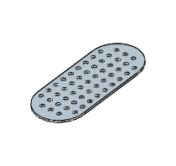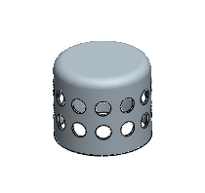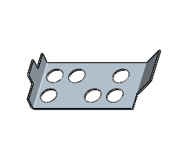
14. Lesson Blend |  |  | 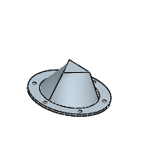
14. Lesson Sweep |  |  | 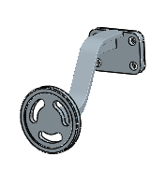
16. Lesson Helical Sweep |  |  | 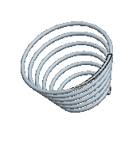
17. Lesson  Drafts |  |  | 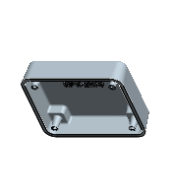
18. Lesson  Shells |  |  | 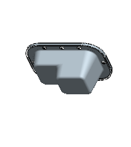

 |  |  | Part and drawing Projects
1. |  |  | 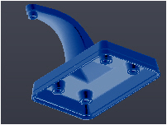
2. |  |  | 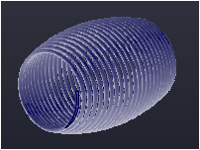
3. |  |  | 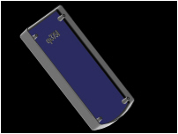
4. |  |  | 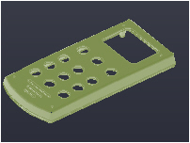
5. Drawing |  |  | 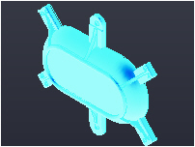
 |  |  | 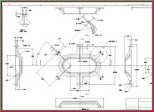

 |  |  | Assembly projects
1. |  |  | 
2. |  |  | 
3. |  |  | 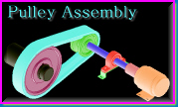

 |  |  | Final Project
1. |  |  | 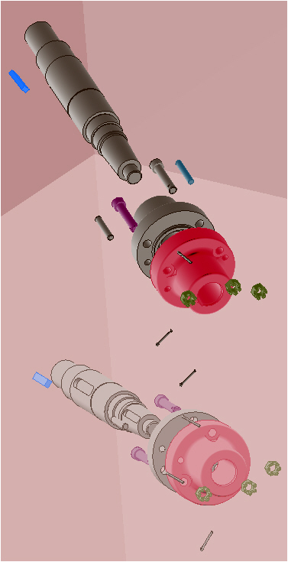
2. |  |  | 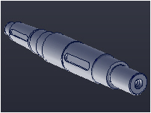
3. |  |  | 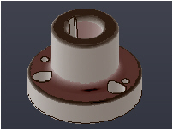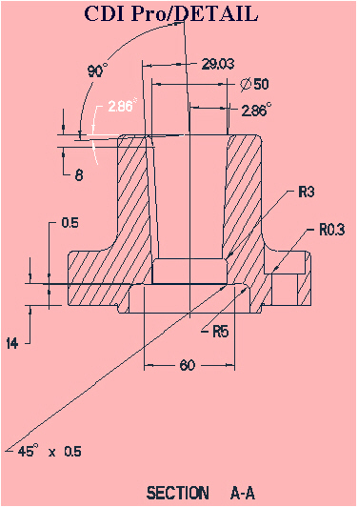
4. Assembly |  |  | 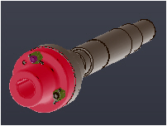
5. Exploded Assembly |  |  | 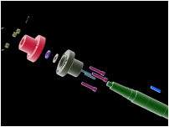
6. Assembly Drawing |  |  | 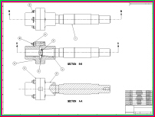



Modeling
If not done in CDI70
Detailing
If not done in CDI70
Assemblies
If not done in CDI70

Advanced Modeling
Advanced Detailing
Advanced Assemblies

Your Email--
Your NAME :
INSTRUCTOR : |  |  |  | WEB SITE www.cad-resources.com
SECTION :

