 | CK. | CDI 58 Unigraphics NX 3 Check Off List
 |  | See www.cad-resources.com–
Tutorials
1. |  | Lamit_UG_Tutorial
2. |  | Lamit_Tutorial_Base_Support
Textbook |  | 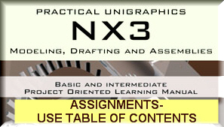
Chapters |  | Design Visionaries
1.
2.
3.
4.
5.
6.
7.
8.
9.
10.
11.
12.
13.
14.
15.
16.
17.
18.
19.
20.
CAST online tutorials |  | 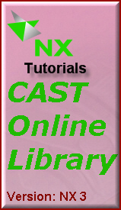
1 |  | An Overview of NX 1 hour
2 |  | NX Essentials 7 hours
3 |  | Sketcher 3 hours
4 |  | Feature Modeling Techniques 6 hours
5 |  | Additional Feature Modeling Techniques 5 hours
6 |  | Practice Projects 2 hours
7 |  | Assembly Modeling 8 hours
8 |  | Drafting Fundamentals 8 hours
9 |  | Drafting for Assemblies 3 hours
Notes

Your Email—

Your NAME
INSTRUCTOR : |  |  | Louis Gary Lamit lgl@cad-resources.com www.cad-resources.com
SECTION : |  | CDI 58

