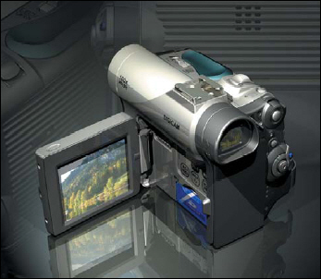
De Anza College CDI58 Unigraphics NX3
Class assignments
Instructor: L Gary Lamit

lgl@cad-resources.com
www.cad-resources.com

Required to complete:
a. Text: Design Visionaries
b. CAST Tutorials: CAST Online Library
c. Tutorial 1 Creating a sketch on a WCS
d. Tutorial 2 Creating a sketch on a face
e. Tutorial 3 Modeling Base Support Part

- 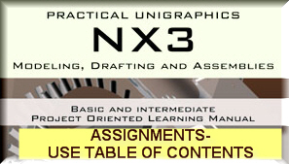 Design Visionaries- complete all of text
- 